# Evaluation of Questionnaire Responses:

## Optional Information:

### *Name:*

* Dan
* Ben
* John

### *Age:*

* 32
* 18
* 26
* 16
* 28
* 21

### *Location:*

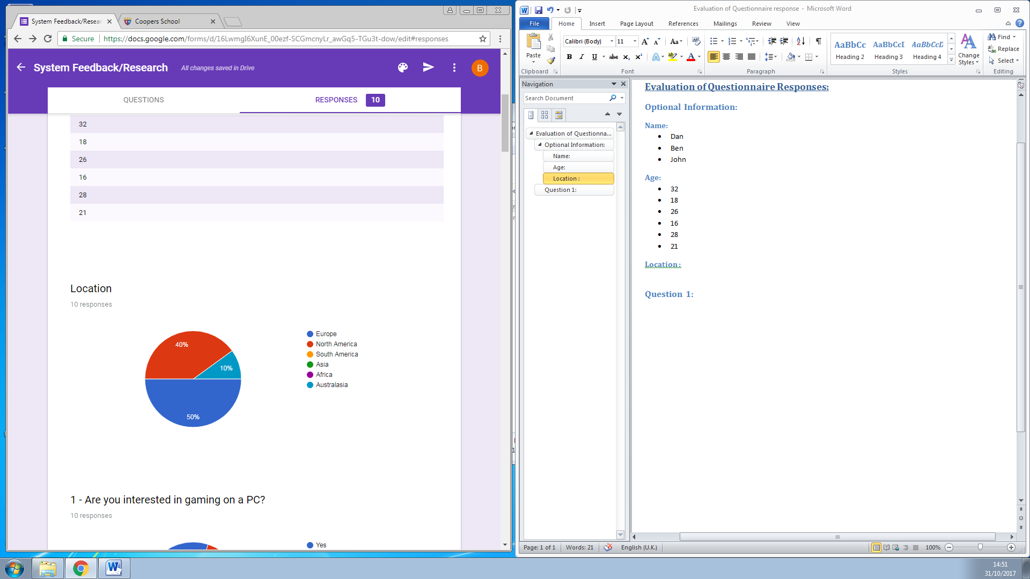

## Question 1:

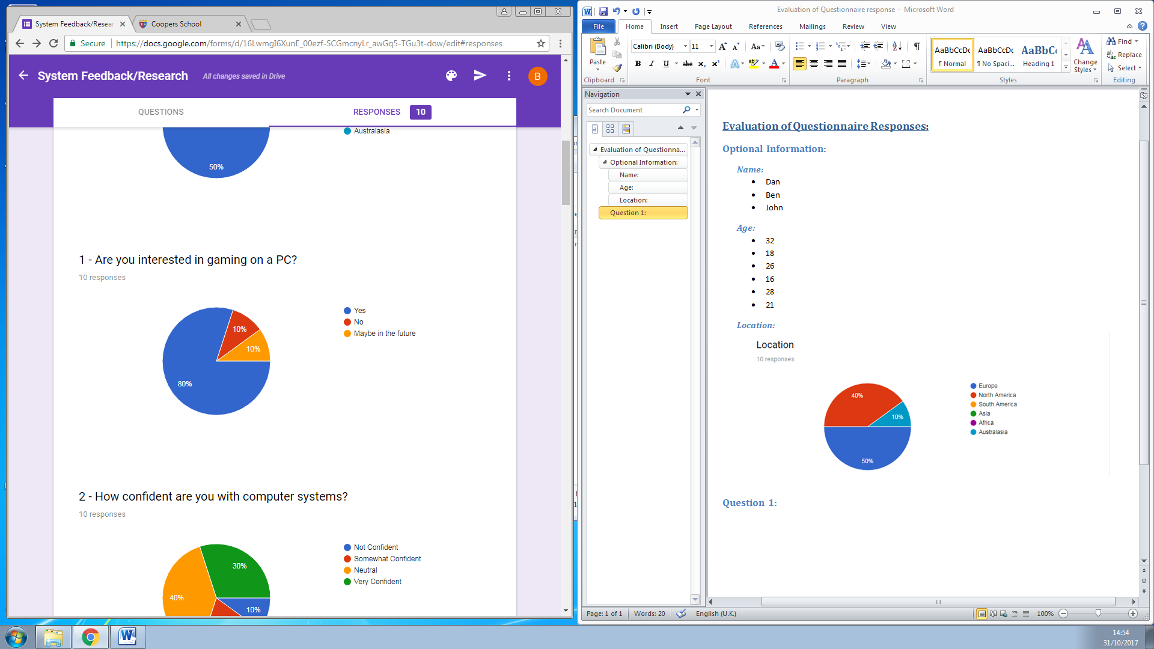

A large majority of people (80%) are definitely interested in gaming on a PC. In addition to this, the one person who did not answer “no” responded that they would be interested in PC gaming “maybe in the future”. This is positive for me since the program I’m going to be taking further is almost entirely orientated around PC gaming and a user’s ability to do so. As said above, of the 10 replies only one (10%) gave the answer ‘no’. This could mean either that the person is genuinely not interested in PC gaming now and in the future, or the person who answered could potentially be an employee or IT administrator who manages programs like mine but doesn’t have an interest in the gaming itself.

## Question 2:

Unfortunately, the responses for this question were widely varied and so I will have to cater my program to those of all different abilities. Fortunately, though, most people were either very confident (30%) or Neutral confidence (40%). Of those who are not confident with computers, though, I can cater a tutorial, guide or generally simplify the experience my program offers. Doing, this though, will allow me to fully understand and improve my program in its entirety to allow people of all computer abilities to use it thus increasing the amount of people who can use it and download it. Given this feedback, and after thinking things through, I’ll likely implement a visual tutorial (IF POSSIBLE) and a small step by step guide inside of the ‘About’ tab. As well as this, to cater for the more advanced users I will likely implement keyboard shortcuts that open up different tabs or complete different functions depending on the key combination that is entered.

## Question 3:

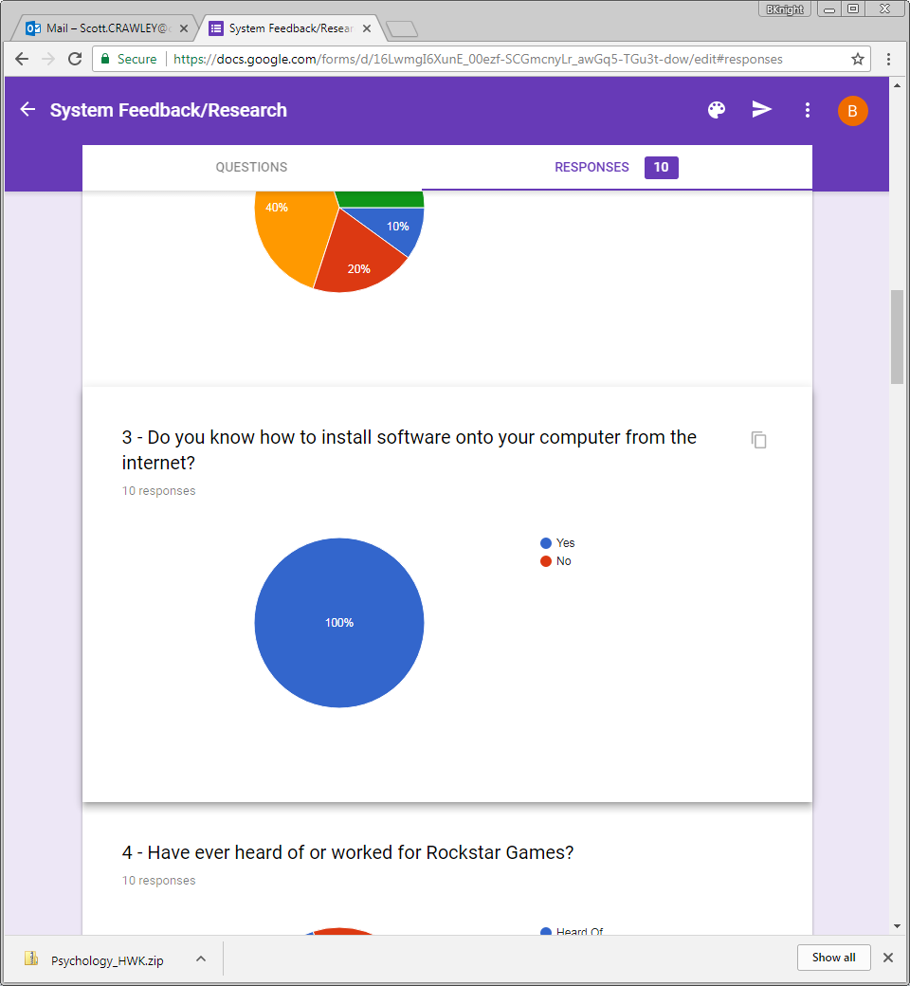

Fortunately, despite the mix computer knowledge and abilities, every single person who completed my questionnaire is aware of how to install software onto their computer from the internet. Were I to receive feedback saying otherwise, I’m not sure what I possibly could’ve done to help with the download process. Now, I can use the client company’s official website or a subsidiary site to host the program for the user to download onto their computers.

## Question 4:

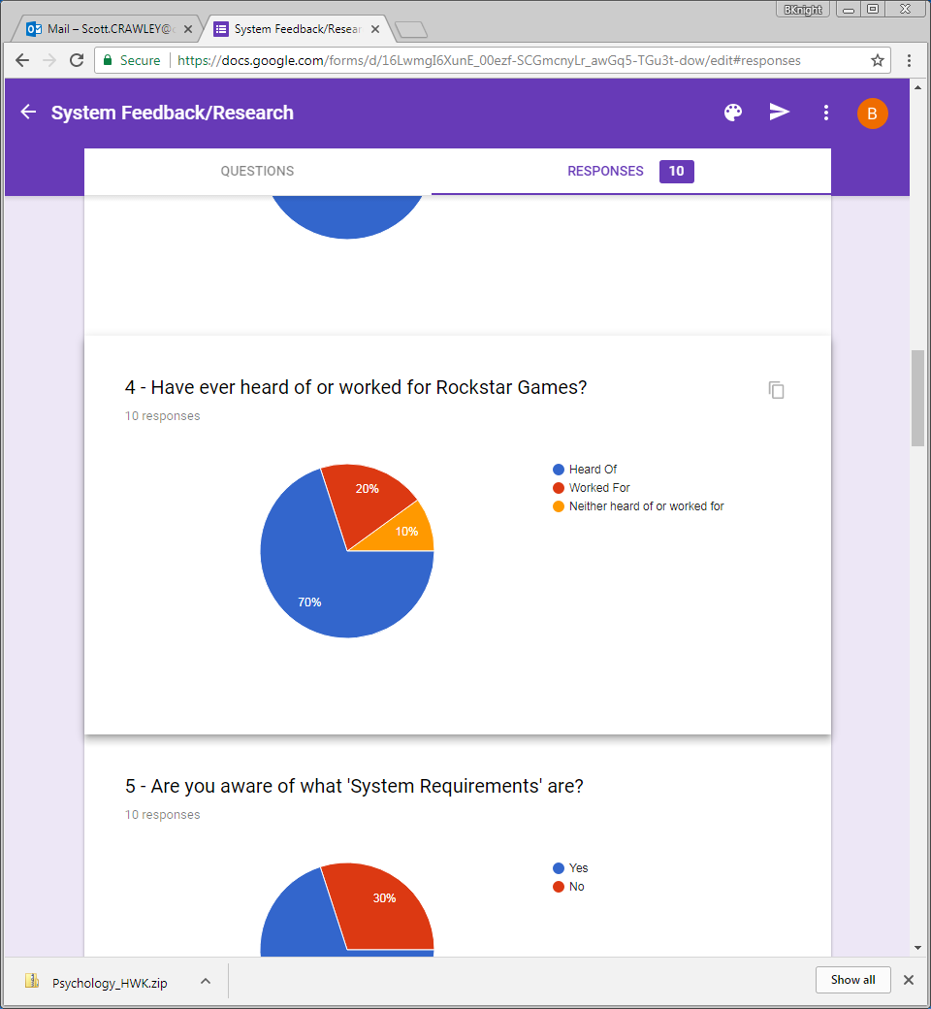

Of the 10 people who completed the survey, 7 (70%) have heard of Rockstar Games – the client company – and 20% had actually worked for them. This shows that the targeted audience/users are able to understand and acknowledge the purpose of a program like mine, were it to exist, and who was the company behind it altogether. Despite this, one person did say that they’ve neither heard of nor worked for Rockstar games. This could be the single “no” given in response to the first question earlier or it could be someone interested in gaming on a PC who isn’t aware of Rockstar as a company. It’s also a possibility that the person could’ve played a Rockstar title before but have never acknowledged them doing so. This feedback shows that I could add some minor information and detail about the client into the ‘About’ tab along with the step by step guide in order to ensure that everyone is aware of the client company and their products.

## Question 5:

In this question, the responses almost directly correlate with Question 3. In Question 3, 30% were ‘Somewhat Confident’ and ‘Not Confident’ whilst the other 70% were either ‘Neutral’ or ‘Very Confident’. Similarly, in this question, we can see that 30% of people are not aware of System Requirements. Therefore it can be assumed that those who are not confident with computer systems are also not aware of System Requirements are. This further reinforces the fact that I’ll need a detailed tutorial, guide or information section in ‘About’ to ensure that everyone is aware of the purpose of the program and to make sure that I can appeal to the mixed abilities of the target audience and users.

## Question 6:

Interestingly, unlike Question 5 and Question 3, 40% of people are unaware of why components are important when playing PC games. This could be the result of the usual 30% of people being naturally unaware and 1 extra person who is new to the PC gaming community as a whole. Once again, this means that I need to ensure that a guide and tutorial are *definitely* added to my program to allow the users to not be overwhelmed.

## Question 7:

Compared to all other questions in this questionnaire, this is the only optional one. I mostly assumed that those who answered ‘yes’ to the previous question would leave a response here. It seems that I was mostly correct but rather 1 more person left a response to this. It’s possible that one of the people who responded to the last question accidentally left a “no” rather than a “yes” – which would explain the unusual 40% percentage – or that there is a person who doesn’t understand why components are important but are aware that the current system that informs people of the required components is very slow. Either is a possibility that leads to the conclusion that I should try to make my program as fast, convenient and detailed as possible to absolutely make sure that users are aware of the system requirements of a particular game whilst remaining as accurate as possible. Additionally, my program should do most if not all of the work for the user since, currently, people must do their own research and investigations into whether or not their personal computer can run a particular game and at what settings.

## Question 8:

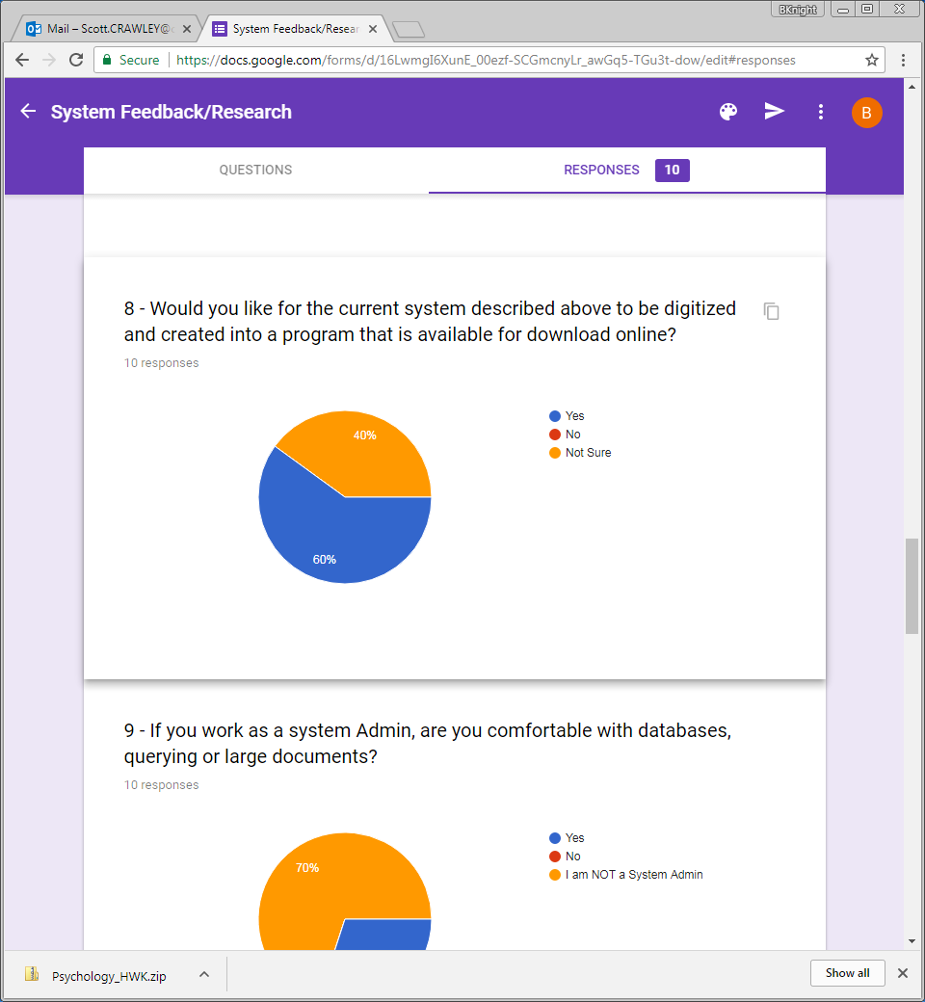

Once again a similar percentage is shown after all responses have been noted. The majority of people who answered were enthusiastic about the rollout of system requirements being turned into a program and it is likely that the majority are the people who are more confident with computer systems. It is likely that the other 40% were those who are less confident with computers. However, fortunately, no one said that they’d not like a program that does the job described above meaning that we can assume that a varied amount of users will use this program. As for those who are not sure, a good tutorial and guide should once again change people’s minds - thus this will be an extremely important focus of mine, given all of the feedback of all of the questions so far, to make my program understandable by everyone and tutorial very detailed.

## Question 9:

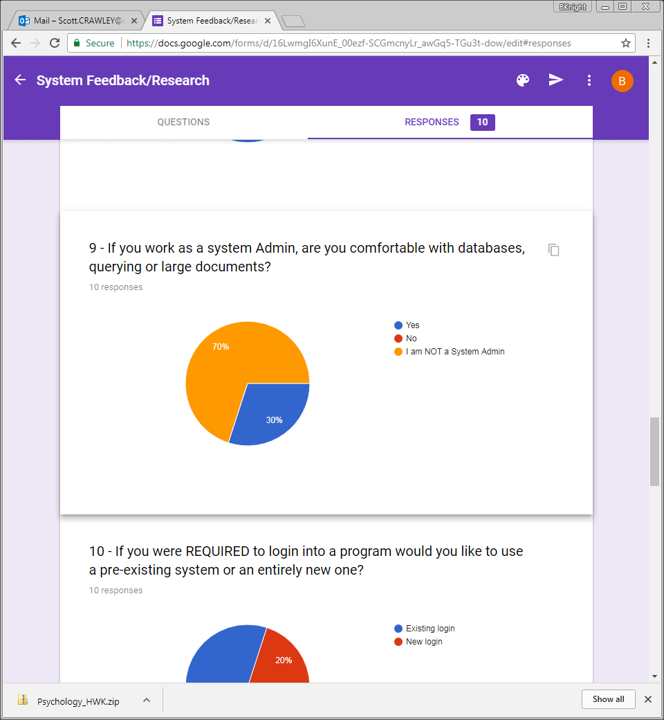

This question provided me with very important information in regards to the staff side and more technical aspects of my program. To manage this system, IT administrators must be able to understand basic databases and querying. Of the 10 responses to this questionnaire, 3 were actual system admins and 100% of them are comfortable with databases and the features associated with them. The other 70% of people were not system admins. In regards to my program in particular, not much needs to be micromanaged and monitored so therefore only 30% of responses being IT admins is perfectly fine and reasonable.

## Question 10:

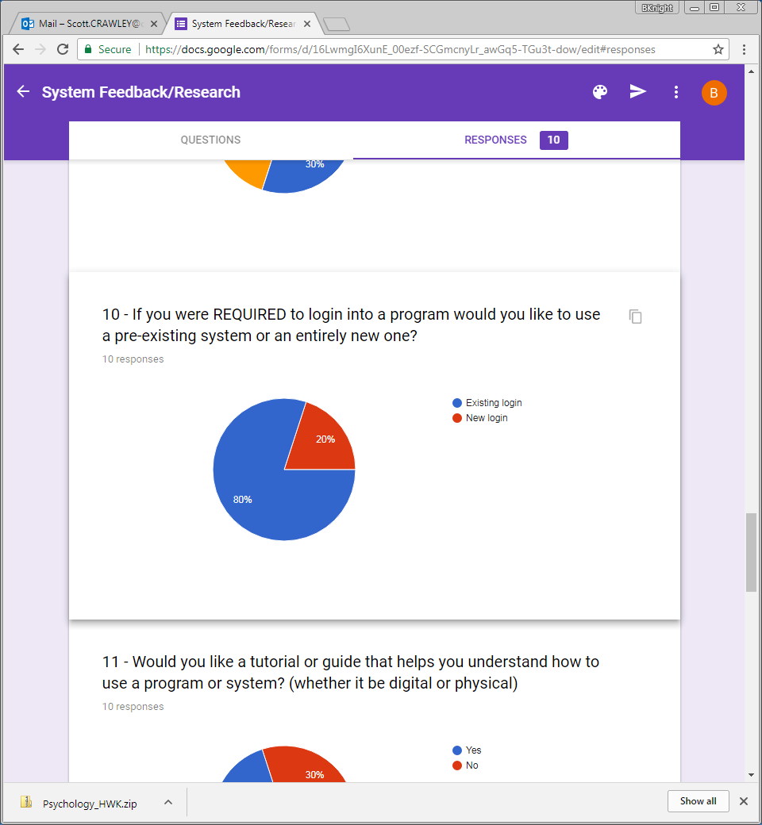

The overwhelming majority of people (80%) very clearly stated that they’d like a pre-existing system to login to the account needed with the program I’ve proposed. This works in my advantage since the client company (Rockstar Games Inc.) already have a network of accounts used to login to their multiple games, programs and associated products called “Rockstar Games Social Club”. This will therefore be used within my program for simplicity and ease of access. *However*, it is very important to note that I do *NOT* legally have permission to access Rockstar Games Social Club account details and thus a simplified and separate system will be incorporated into my program which will share the logo and design of the Social Club network.

## Question 11:

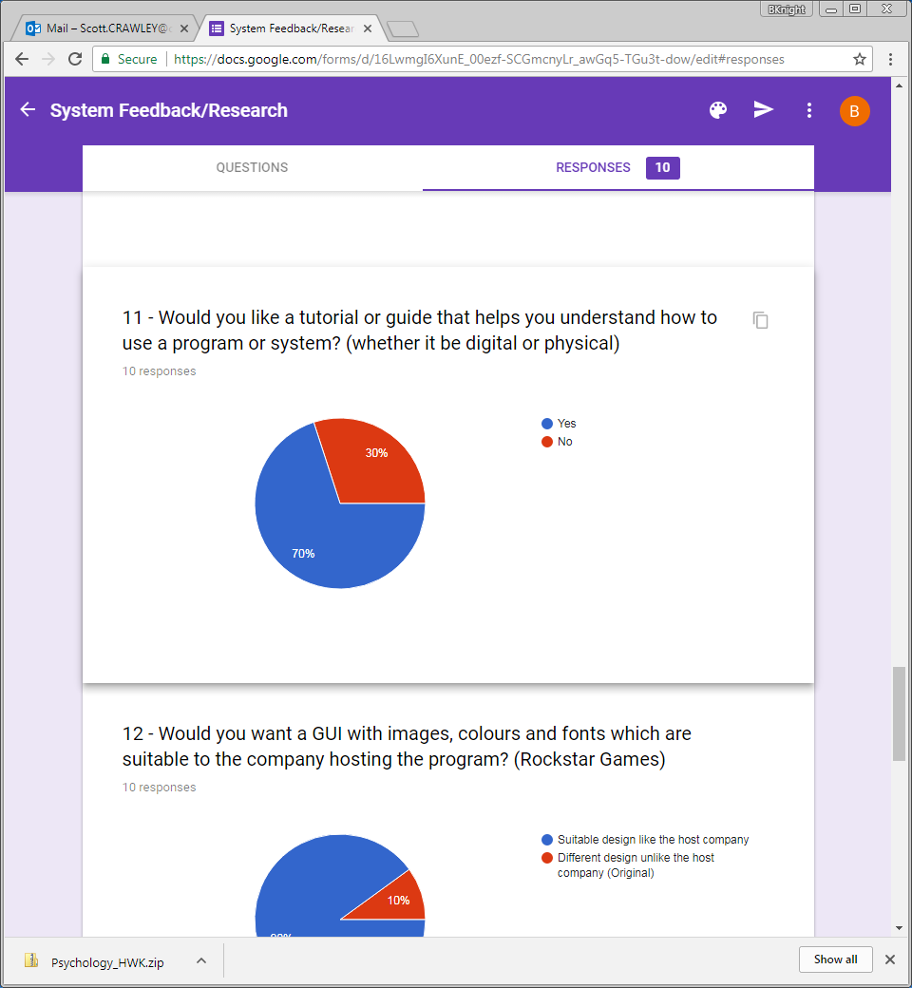

Despite the replies given above, I have come to the conclusion that a guide or tutorial is a vital function that should be incorporated into my program. This conclusion was drawn from the fact that many people aren’t completely confident or aware of computer systems, hardware and the important role they play in PC gaming. However, upon taking note of the responses above, we can see that the majority of people were still quite keen on a guide (digital or physical). Only 30% claimed the opposite – that they did not need a guide. This 30% was more than likely the more advanced tier users who were interviewed. Overall, though, the tutorial implemented with my program will definitely be digital and somewhat interactive/visual. On top of this, there will also be a step-by-step process on how to use the program inside of the ‘About’ tab.

## Question 12:

*“GUI” will be changed to “interface”

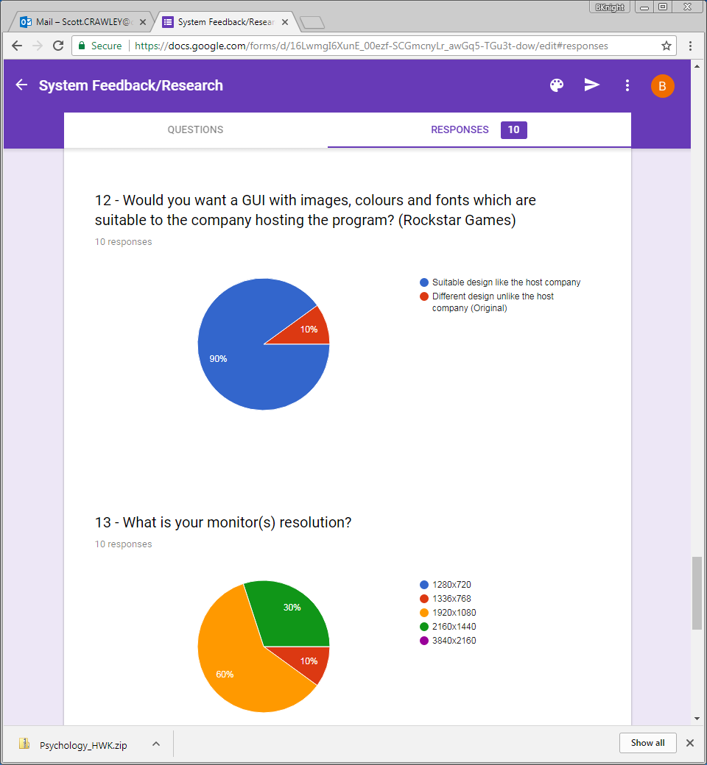

An overwhelming majority (90%) decided that they’d prefer the design of the program to be suitable and like the client company instead of completely original. This combined with the decision to use the Social Club logo and general design will allow me to have a much more direct and clear aesthetic objective which should speed up the design process when creating the front-end of the program.

## Question 13:

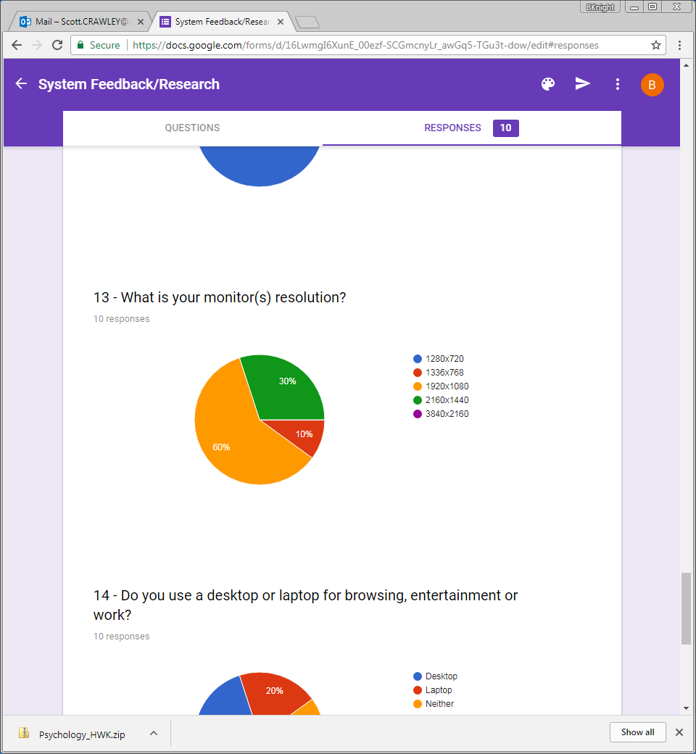

Question 13 is an important question since my program will likely need to be catered towards many different resolutions. This means that the way the program’s assets are used would be completely different compared to if the resolution remained the same. Despite this, we can see that 90% of people had a resolution equal to or bigger than 1920x1080. This allows me to come to the conclusion that the resolution of my program should be around 1000x1000 pixels. This will allow it to fit onto the smaller screen sizes of those in the minority whilst still remaining big enough for larger resolution monitors. This decision will also be easier for me to code since organising the assets to resize in proportion with the program’s resolution would be much more difficult. The main problem with a program like that would be trying to ensure that the layout of the program is not affected by the change in resolution – something which would be very likely. The decision to keep the resolution the same size does mean that it will not working for much smaller screens but it also means that the program will be higher quality and produced at a faster rate.

## Question 14:

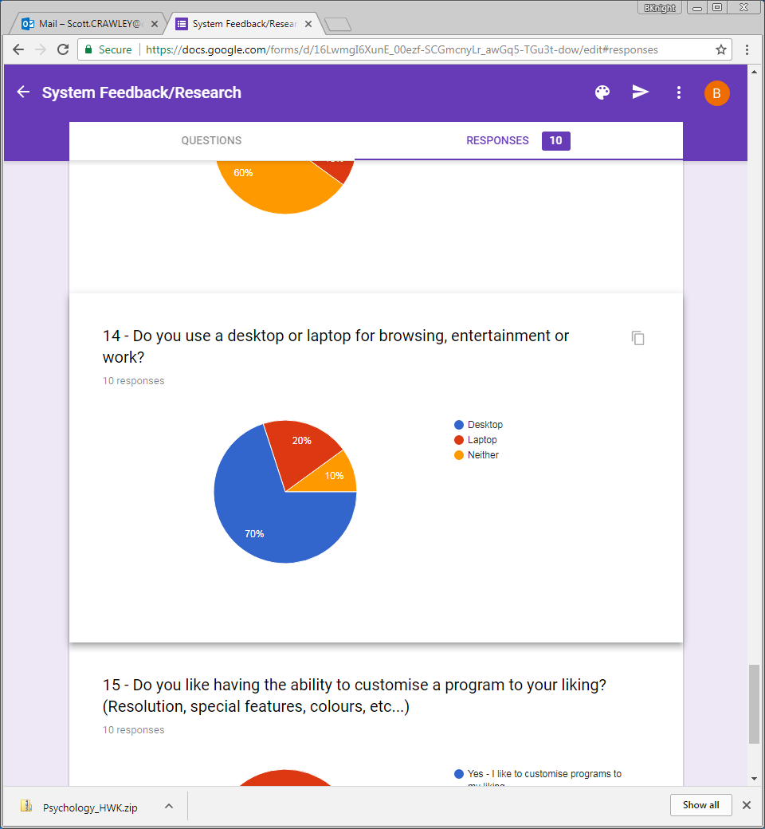

The responses to this question show me just how important it is for someone to be able to access the program and how important it is for someone to be using it to their advantage. For example, in the event of many people using laptops, it would be clear that I’d need to introduce shortcuts and support for a trackpad whilst in the event of many people using desktops I would have much more freedom in terms of the ways to navigate through the program – like using the mousewheel to scroll down on a page. In this scenario, the vast majority of people (70%) are using desktops in their everyday lives and so I can introduce more complex shortcuts and accessibility features such as the mousewheel function mentioned above.

## Question 15:

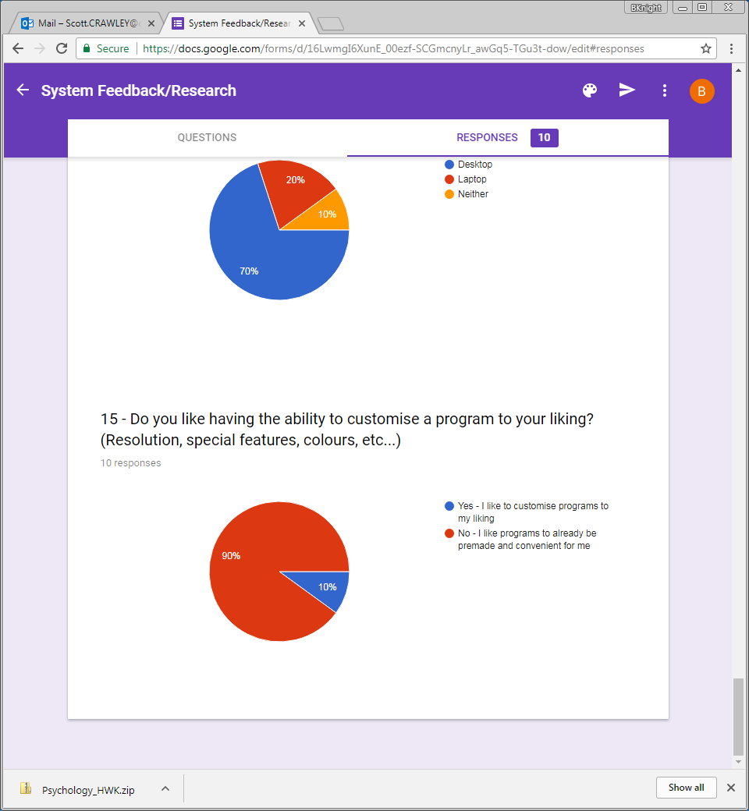

Question 15 is one of two other questions where the overwhelming majority of people (90%+) voted for one particular option; the program to be premade and convenient for them. This further gives me reinforcement for the decision to use a predefined design, logo, system and even resolution. Many people would like for this program to include most things such as for them however some basic customisation options will still be supplied to the more advanced/disadvantaged users such as the ability to use a set of keyboard shortcuts or use a colour blind mode and night mode. Many other options could be added in the development process of the program to ensure a high quality finish and pleasant experience for the user. This will also appeal to all of the people who answered my questionnaire.